**PART A**

(Part A: TO BE REFFERED BY STUDENTS)

**Experiment No. 03**

**A.1 AIM:**

Create class time table using Tables in HTML

**A.2 Pre requisite:**

Basic Knowledge of HTML and HTML tags

**A.3 Outcome:**

After successful completion of this experiment students will be able to:

1. Design their class time table using HTML table tags
2. Understand various table tags and their attributes

**A.4 Theory:**

The HTML tables allow web authors to arrange data like text, images, links, other tables, etc. into rows and columns of cells.

The HTML tables are created using the <table> tag in which the <tr> tag is used to create table rows and <td> tag is used to create data cells. The elements under <td> are regular and left aligned by default

**Table Heading**

Table heading can be defined using <th> tag. This tag will be put to replace <td> tag, which is used to represent actual data cell. Normally you will put your top row as table heading as shown below, otherwise you can use <th> element in any row. Headings, which are defined in <th> tag are centered and bold by default.

**Cellpadding and Cellspacing Attributes**

There are two attributes called cellpadding and cellspacing which you will use to adjust the white space in your table cells. The cellspacing attribute defines space between table cells, while cellpadding represents the distance between cell borders and the content within a cell.

**Colspan and Rowspan Attributes**

You will use colspan attribute if you want to merge two or more columns into a single column. Similar way you will use rowspan if you want to merge two or more rows.

**Tables Backgrounds**

You can set table background using one of the following two ways −

bgcolor attribute − You can set background color for whole table or just for one cell.

background attribute − You can set background image for whole table or just for one cell.

You can also set border color also using bordercolor attribute.

**Table Height and Width**

You can set a table width and height using width and height attributes. You can specify table width or height in terms of pixels or in terms of percentage of available screen area.

**Table Caption**

The caption tag will serve as a title or explanation for the table and it shows up at the top of the table. This tag is deprecated in newer version of HTML/XHTML.

**A.5 Procedure/Task:**

1. Create a Time Table.

2. Use HTML table tags to make your time table

7. Prepare the document. Save and close the file and name it as **EXP03_Roll no_Batch no.**

**PART B**

(PART B: TO BE COMPLETED BY STUDENTS)

(Students must submit the soft copy as per following segments within two hours of the practical. The soft copy must be uploaded on the Blackboard or emailed to the concerned lab in charge faculties at the end of the practical in case the there is no Black board access available)

|  |  |
| --- | --- |
| Roll No.: N049 | Name: Tarun Tanmay |
| Class : MBATech CE | Batch: B3 |
| Date of Experiment : 18-07-2020 | Date/Time of Submission : |
| Grade : |  |

**B.1 Code:**

<html>

<head>

<title> TIME TABLE </title>

</head>

<body>

<h3 align="center">

SVKM's NMIMS <br>

Mukesh Patel School Of Technology Management And Engineering <br>

(Mumbai Campus) A.Y. 2020-2021 <br>

Course: MBA Tech CE &nbsp&nbsp&nbsp&nbsp&nbsp Div: B &nbsp&nbsp&nbsp&nbsp&nbsp Sem: 5 &nbsp&nbsp&nbsp&nbsp&nbsp Class Room: 54

<table border="1" width=900PX align="center">

<tr align="center">

<th></th>

<th colspan=3> MONDAY </th>

<th colspan=3> TUESDAY </th>

<th colspan=3> WEDNESDAY </th>

<th colspan=3> THRUSDAY </th>

<th colspan=3> FRIDAY </th>

<th colspan=3> SATURDAY </th>

</tr>

<tr align="center">

<th>8:00-9:00</th>

<td colspan=3></td>

<td colspan=3></td>

<td colspan=3></td>

<td rowspan=2 colspan=3>PELA <br>[VVM]</td>

<td rowspan=2>DAA <br> B3 <br> [RCH]</td>

<td rowspan=2>WP<br> B2 <br> [VRG] </td>

<td rowspan=2>DM<br>B1<br>[ABI]</td>

<td rowspan=2>WP<br>[VRG]</td>

</tr>

<tr align="center">

<th>9:00-10:00</th>

<td colspan=3></td>

<td colspan=3></td>

<td colspan=3>CN<br>[PKH]</td>

</tr>

<tr align="center">

<th>10:00-11:00</th>

<td rowspan=2 colspan=3>CN<br>[PKH]</td>

<td rowspan=2 colspan=3>HCI<br>B1<br>[VPP]</td>

<td rowspan=2>CN <br> B3<br>[PKH]</td>

<td rowspan=2>IP<br> B2 <br>[PRN]</td>

<td rowspan=2>DAA<br>B1<br>[RCH]</td>

<td colspan=3>IP<br>[PRN]</td>

<td rowspan=2 colspan=2>HCI<br>[VPP]</td>

<td rowspan=2> WS<br>[AVI]</td>

<td colspan=3>DM<br>[ABI]</td>

</tr>

<tr align="center">

<th>11:00-12:00</th>

<td colspan=3>LUNCH</td>

<td colspan=3>LUNCH</td>

</tr>

<tr align="center">

<th>12:00-13:00</th>

<td colspan=3>IP<br>[PRN]</td>

<td colspan=3>LUNCH</td>

<td colspan=3>DM<br>[ABI]</td>

<td rowspan=2>IP <br> B3<br>[PRN]</td>

<td rowspan=2>DAA<br> B2 <br>[RCH]</td>

<td rowspan=2>CN<br>B1<br>[PKH]</td>

<td colspan=3>IP<br>[PRN]</td>

<td colspan=2 rowspan=2>WP<br>B3<br>[HMO]</td>

<td rowspan=2> DM<br>B2<br>[ABI]</td>

</tr>

<tr align="center">

<th>13:00-14:00</th>

<td colspan=3>LUNCH</td>

<td colspan=3>DM<br>[ABI]</td>

<td colspan=3>LUNCH</td>

<td colspan=3>LUNCH</td>

</tr>

<tr align="center">

<th>14:00-15:00</th>

<td rowspan=2 colspan=3>DAA<br>[RCH]</td>

<td rowspan=2>DM <br> B3<br>[ABI]</td>

<td rowspan=2>CN<br> B2 <br>[PKH]</td>

<td rowspan=2>IP<br>B1<br>[PRN]</td>

<td colspan=3>DAA<br>[RCH]</td>

<td rowspan=2 colspan=3>WS<br>B2<br>[AVI]</td>

<td rowspan=2 colspan=3>HCI<br>B2<br>[VPP]</td>

<td colspan=3></td>

</tr>

<tr align="center">

<th >15:00-16:00</th>

<td colspan=2>HCI<br>[VPP]</td>

<td > WS<br>[AVI]</td>

<td colspan=3></td>

</tr>

<tr align="center">

<th>16:00-17:00</th>

<td rowspan=2 colspan=3>WP<br>B1<br>[HMO]</td>

<td colspan=3> BREAK </td>

<td rowspan=2 colspan=3> WS <br>B1 <br>[AVI]</td>

<td colspan=3> BREAK </td>

<td rowspan=2 colspan=3>ML<br>[ABH]</td>

<td colspan=3></td>

</tr>

<tr align="center">

<th>17:00-18:00</th>

<td colspan=3>ML<br>[ABH]</td>

<td rowspan=2 colspan=3>ML<br>[ABH]</td>

<td colspan=3></td>

</tr>

</tr >

<tr align="center">

<th >18:00-19:00</th>

<td colspan=3></td>

<td colspan=3></td>

<td colspan=3></td>

<td colspan=3></td>

<td colspan=3></td>

</tr>

</table>

**B.2 Output**

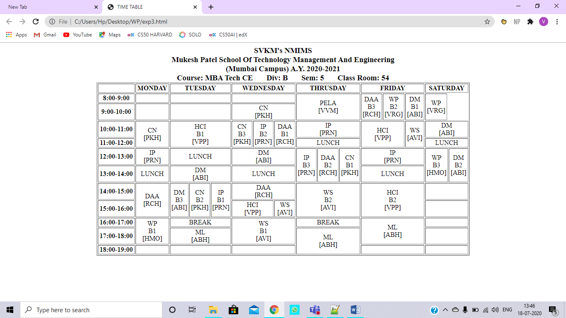

**B.3 Conclusion:**

After performing the above experiment, we can conclude that we have learnt to work with the various tabs of a table. We can easily modify our table by merging cells row or column wise.

**B.3 Observations and Learning:**

In the above experiment, we learnt two very important properties of the table tab: rowspan which helps us merge two or more cells of a column. The colspan property helps us merge two or more cells in a single row.

**B.4 Question of Curiosity**

Q1. Explain Nested Tables.

Nested tables are created when one table is created inside another table.

The syntax for a nest table would look like:

<table>

…

<table>

…

</table>

….

</table>

The nested table may contain one then just a single table inside it.

Q2. Write a code for generating nested table.

<html>

<head>

<title> Nested Table </title>

</head>

<body>

<table border="1" align="center">

<tr align="center">

<td>

LEFT SIDE OF MAIN TABLE

</td>

<td>

<table border="1" align="center">

NESTED TABLE

<tr>

<td> LEFT OF NESTED TABLE </td>

<td> RIGHT OF NESTED TABLE </td>

</tr>

</table>

</td>

</tr>

</table>

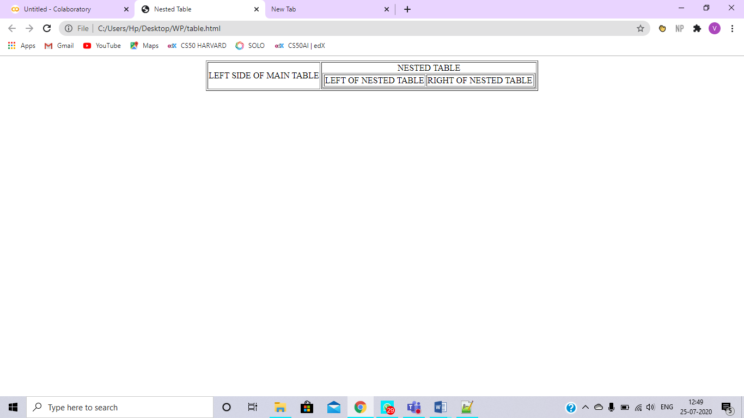

Q3. Why are tables used for webpage designing in HTML? Answer with appropriate reason.

Tables are important while designing a webpage because:

* They can be used to create real world like tables on the web page.
* Tables can be used for placing elements on the web page easily as they provide a structured layout. We can use this layout to place elements on our page and can hide the borders of the table so its looks neat.